Branded Clothing Order Form
Name:___________________________________

Session attending:
Dance Junction 12-16 Theatre Junction 12-16
COMPANY b Dance 16-25 COMPANY b Theatre 16-25
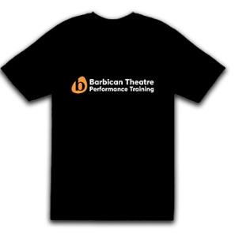
T- Shirts - £8 (In box please put quantity as well)
100% cotton. Machine washable.
Small (size to fit chest 35-37”, length 69.5”)
Medium (size to fit chest 38-40”, length 72”)
Large (size to fit chest 41-43”, length 74.5”)

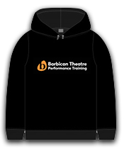
Hoodie - £18 In box please put quantity as well)
80% ringspun cotton/20% polyester. Machine washable.
Small (size to fit chest 36”, length 67”)
Medium (size to fit chest 40”, length 70”)
Large (size to fit chest 44”, length 73”)

Total to pay: __________________

Signature: ______________________Date: ___________________________

Please hand completed form into your class Practitioner or to James Woodhams (in the main office) along with payment (cash, debit or credit card of cheque made payable to Barbican Theatre)

For office use:
Payment received: Cash Card Cheque
Item(s) supplied to participant Membership number: ___________________________

